Table of Contents

Chapter One: Introduction 2
Chapter Two: The Importance of Sleep 9
Chapter Three: What is Sleep Disordered Breathing? 72

Chapter One: Introduction

Chapter Name: Introduction
Learning Objectives:
- Introduce the purpose of the course
- Identify course structure

Screen Number:
Screen Title |  | Introduction
Screen layout or graphic


 |  |  | Multiple screens for detail (Y/N)? |  |  |  | N
Development:  Actions/Callouts/  Interactivity |  |  |  |  | Onscreen Text |  |  |  | Audio Script
ResMed PPT Template Graphics appear onscreen.

Need to get the template or master PPT slides from Naomi and Graphics team. We will also need the style sheet for declaring fonts, size, cascading styles, etc.
 | Course name fades onto screen into top horizontal graphic then fades out. |  |  |  | The Anatomy of Sleep and Sleep Disordered Breathing
 | TBD:  Message about approximate duration of this course. 2 hours? Seems to be longer.  Will there be the ability to complete this course in segments? Need to define where a learner can start, pause, etc. Chapter Level? |  |  |  | Course Approximate Duration – presented on screen.
 | The Clinician (Lucas) image fades onto screen into the right-center of the screen.  During Lucas’ introduction the onscreen text appears and his image pulls to the right.  Note: Onscreen text displays at the same time the audio script is delivered. |  |  |  | Hello! Welcome to The Anatomy of Sleep and Sleep Disordered Breathing Course.  - Raise Awareness of Sleep Disordered Breathing (SBD).  - Understand the importance of sleep, what SDB is and how seriously SDB impacts our health.  - Throughout this course you will meet different people. Use your newly-acquired knowledge to raise their awareness about the importance of sleep and the impact of SDB. |  |  |  | Hello! Welcome to The Anatomy of Sleep and Sleep Disordered Breathing (SDB).  My name is Lucas and I’m the clinician who will guide you through this course. I work with patients every day, and I’m willing to bet that you know or have met some people who have SDB (even if they don’t know it yet).  Even if you don’t know any, the fact is that you speak with people every day and sometimes you may have the opportunity to talk about sleep. It is possible to raise awareness of sleep disordered breathing (SDB) by talking to just one person at a time, but only if you know what to look for and how to talk about it.  By understanding the importance of sleep, what SDB is and how seriously SDB impacts on our health you will be able to speak confidently about sleep and the effects of SDB with anyone.  Throughout this course you will meet different people. I encourage you to use your newly-acquired knowledge to raise their awareness about the importance of sleep and the impact of SDB.  Shortly, you will meet the narrator. They will share with you the core information about the Anatomy of Sleep and Sleep Disordered Breathing.
 |  |  |  |  | Navigation: | Auto-continue

Chapter Name: Introduction
Screen Number:
Screen Title |  | Overview
Screen layout or graphic



 |  |  | Multiple screens for detail (Y/N)? |  |  |  | N
Development:  Actions/Callouts/  Interactivity |  |  |  |  | Onscreen Text |  |  |  | Audio Script
 | The Clinician (Lucas) appears onscreen, but in a different pose than what was on the previous screen.  The Course Goals display. Note: Onscreen text displays at the same time the audio script is delivered. |  |  |  | Course Goals  - Identify patients who have sleep breathing disorders.  - Offer them a treatment that will allow them to live a healthier, happier life. |  |  |  | At the end of the day, our goal is to identify patients who have sleep breathing disorders and offer them a treatment that will allow them to live a healthier, happier life. To understand the importance of this treatment, this course will follow the path a patient might take.
 | Graphic of Lucas fades-out and graphic of someone sleeping displays  Getting Started content. Note: Onscreen text displays at the same time the audio script is delivered. |  |  |  | Getting Started  - Define normal sleep  - Define events that occur during sleep.  - Explore potential causes that change sleep.  - Explore potential consequences if sleep disorder is left untreated. |  |  |  | It will begin with an explanation of normal sleep, then it will go on to explain the changes that occur in a person’s sleep before they realize they have a problem (events that occur while they are sleeping).  The course will go on to explore what might cause these events and will discuss what might happen to the person if the disorder is left untreated. The course will wrap up with an explanation of how a person can be diagnosed and treated.
 |  |  |  |  | Navigation: | Auto-continue

Chapter Name: Introduction
Screen Number:
Screen Title |  | Course Menu
Screen layout or graphic


 |  |  | Multiple screens for detail (Y/N)? |  |  |  | N
Development:  Actions/Callouts/  Interactivity |  |  |  |  | Onscreen Text |  |  |  | Audio Script
 | The Clinician (Lucas) appears onscreen, but in a different pose than what was on the previous screen. Maybe just his upper body?  NM Comment: NOTE: The onscreen text corresponds to the chapters of the course. Maybe instead of bulleted text popping up, the menu icon for that chapter pops up.  Onscreen text displays at the same time the audio script is said/delivered. |  |  |  | - The characteristics and components about of normal and abnormal sleep  - How SDB is defined  - What problems can lead to or exacerbate SDB  - The consequences of untreated SDB  - How patients are screened and diagnosed for SDB  - What treatment options are available for SDB |  |  |  | In order to build the foundation of knowledge about sleep and SDB you will learn about:  - The characteristics and components about of normal and abnormal sleep  - How SDB is defined  - What problems can lead to or exacerbate SDB  - The consequences of untreated SDB  - How patients are screened and diagnosed for SDB  - What treatment options are available for SDB  Armed with this knowledge, you can successfully increase awareness of SDB one person at a time.
 | TBD: If a navigation bar is included (left-hand) side(?). Illuminate these areas/chapters when the audio script is delivered so the learner knows how/where they can access specific sections/content. |  |  |  |  |  |  |  | Before we get started, let me share with you the navigation features of the course.  TBD:  Forward, Back, Stop/Pause, Play/Restart, and Help.
 | Glossary Illuminated showing how to use the glossary. |  |  |  |  |  |  |  | There is also a glossary to help you if you need to define any
 | The Clinician (Lucas) appears onscreen, but in a different pose than what was on the previous screen. Maybe just his upper body? |  |  |  |  |  |  |  | The Clinician (Lucas) shares – Now that you have heard the basic sections that make up this course, let’s get started!
 |  |  |  |  | Navigation: | User-continue

Chapter Two: The Importance of Sleep

Chapter Name: The Importance of Sleep
Learning Objectives:
- Describe basic functions of sleep
- Explain the importance of healthy sleep
- Identify common sleep disorders, including SDB

Screen Number:
Screen Title |  | Introduction
Screen layout or graphic

 |  |  | Multiple screens for detail (Y/N)? |  |  |  | N
Development:  Actions/Callouts/  Interactivity |  |  |  |  | Onscreen Text |  |  |  | Audio Script
 | Image of the Narrator? Do you feel this is needed to give a face with a voice? If not, please disregard and proceed to row “B”. Or can we leverage what Lucas shares in the slide above. |  |  |  |  |  |  |  | NM Comment: Note: If we do decide to have an additional voice for the narrator, I think we probably shouldn’t introduce the narrator as a character, they can just start speaking. I’m still mulling this over, though.  Hello! Welcome to The Anatomy of Sleep and Sleep Disordered Breathing.  My name is ______ and I’m the Narrator who will present a lot of the specific information on the Anatomy of Sleep and Sleep Disordered Breathing. Lucas and I will work together to help provide you with a better understanding of SBDs.
 | Image measuring healthy sleep? (e.g. Circadian rhythm?, person who looks like they do not have healthy sleep patterns.)  Onscreen text displays at the same time the audio script is said/delivered. |  |  |  | This chapter will cover:  - The basics of sleep  - Healthy sleep  - Common sleep disorders |  |  |  | Sleep Disordered Breathing is a disorder that occurs during sleep.  In order to understand SDB and its impact, you must first understand the importance of sleep and what normally occurs.  This chapter will cover:  - The basics of sleep  - Healthy sleep  - Common sleep disorders
 |  |  |  |  | Navigation: | Auto-continue

Chapter Name: The Importance of Sleep
Screen Number:
Screen Title |  | Basics of Sleep: Why do we sleep?
Screen layout or graphic
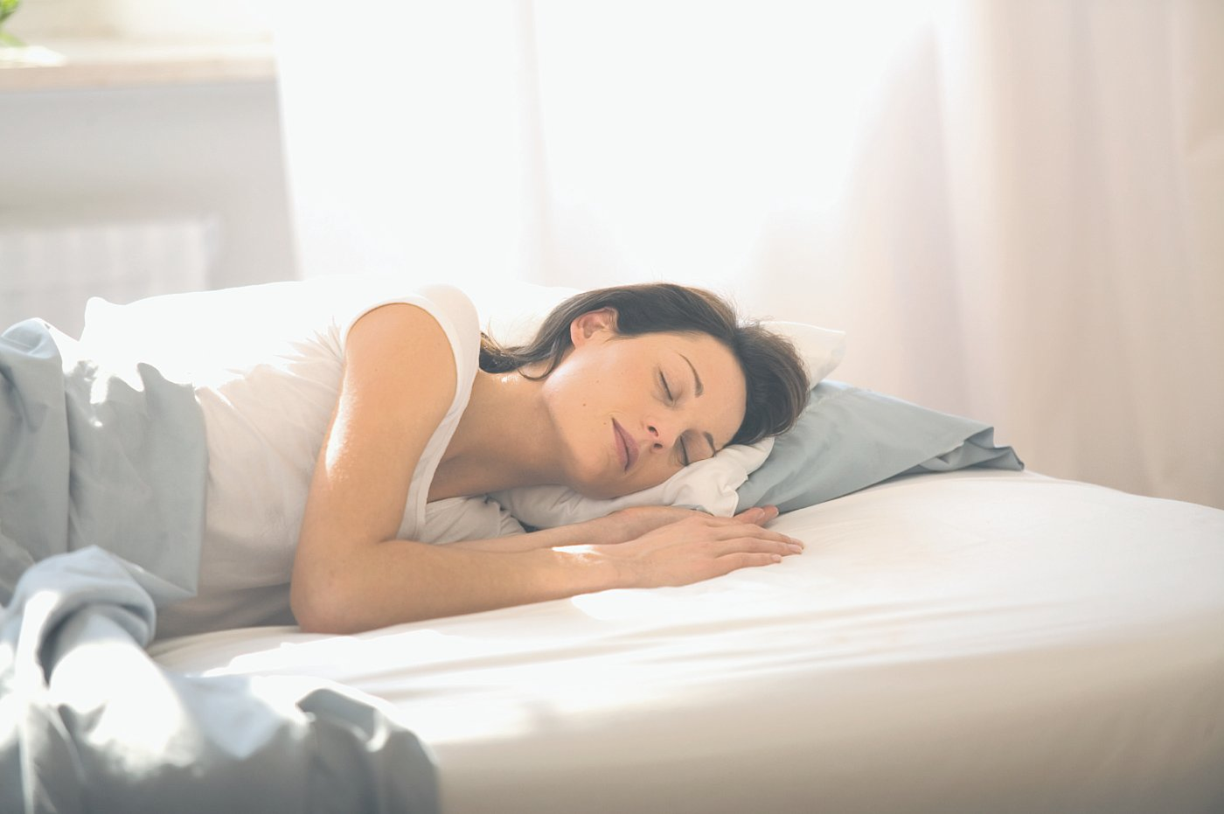


Need Image of someone reading/learning
 |  |  | Multiple screens for detail (Y/N)? |  |  |  | N
Development:  Actions/Callouts/  Interactivity |  |  |  |  | Onscreen Text |  |  |  | Audio Script
 | Image measuring healthy sleep? (e.g. Circadian rhythm?, person who looks like they do not have healthy sleep patterns.)  Above image fades-out and the onscreen text displays at the same time the audio script is delivered.  To the right side of the bullets, images display that convey bullet messages.  Need a picture of someone reading? Learning?  Onscreen text displays at the same time the audio script is said/delivered. |  |  |  | Sleep  - Allows for metabolic restoration of the brain and body  - Heightens our alertness and motivation  - Provides us with the energy to accomplish our goals  - Improves our learning ability. |  |  |  | We do not really understand why we sleep, although we do know that it is restorative for both the body and the brain.  There are several theories as to why we sleep; it:  - allows for metabolic restoration of the brain and body  - heightens our alertness and motivation  - provides us with the energy to accomplish our goals  - improves our learning ability.
 |  |  |  |  | Navigation: | Auto-continue

Chapter Name: The Importance of Sleep
Screen Number:
Screen Title |  | Basics of sleep: What causes us to sleep?
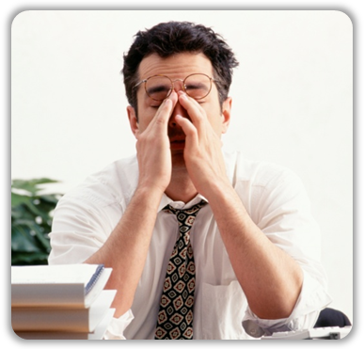Initial screen layout or graphic

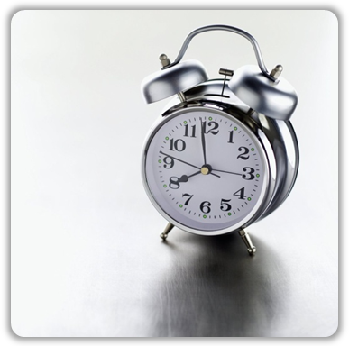 Want to know more? (Click goes to Clinician)
screen layout for Explore Homeostatic Sleep
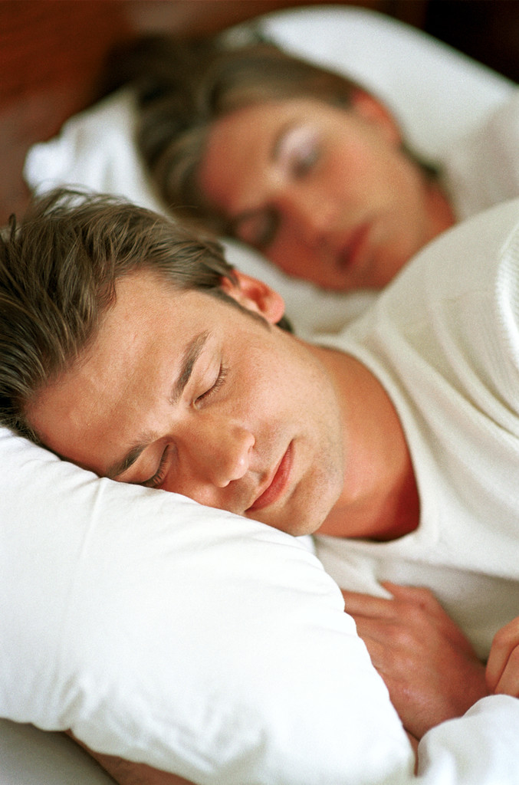

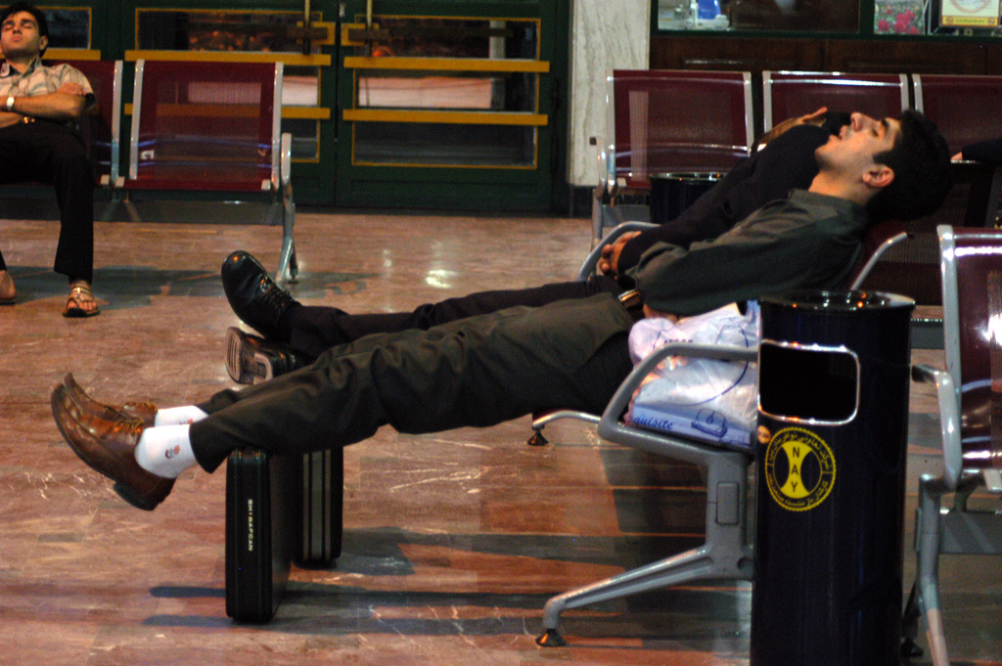
screen layout for Explore Circadian rhythms
Naomi – after this slide may be a good place to introduce the patients as this appears to be the genesis for sleep habits.

Maybe provide a bit about them here as the slide defines sleep. Not sure what variables of the patients need to be delivered her, but at least and intro about them.

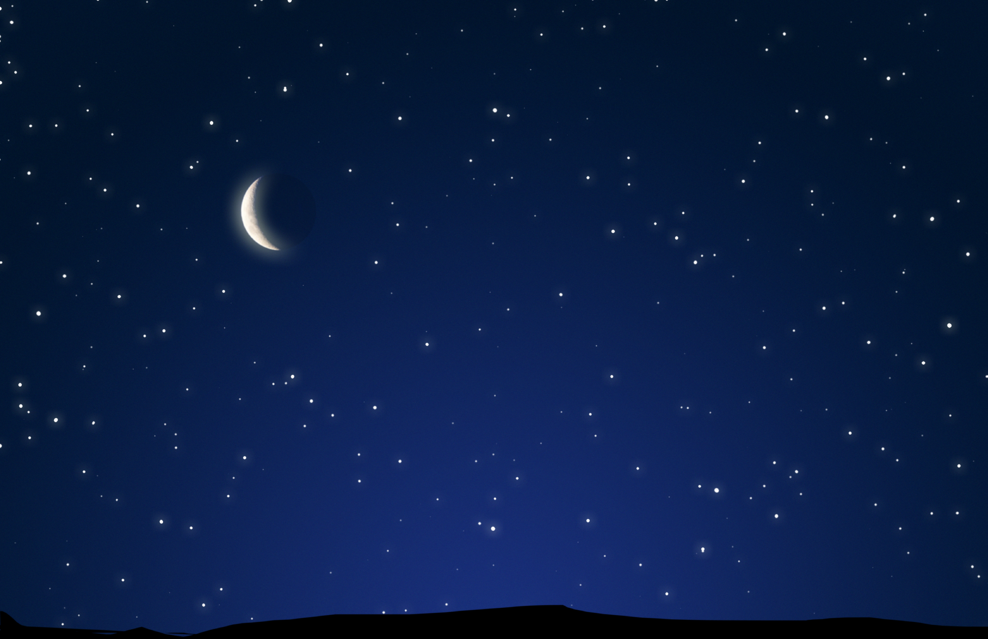
 |  |  | Multiple screens for detail (Y/N)? |  |  |  | Y
Development:  Actions/Callouts/  Interactivity |  |  |  |  | Onscreen Text |  |  |  | Audio Script
 | Image (e.g. Homeostatic Sleep Drive and Circadian rhythm)  Onscreen text displays at the same time the audio script is said/delivered.  After audio script is delivered, the “Click the explore process statement displays.  Note: both processes must be displayed by the learner before the slide will advance.  Note: Per Naomi’s request, wherever the “EXPLORE” information was pulled from the outline (in this or the succeeding slides), I did not abbreviate or summarize the onscreen text or Audio Script. |  |  |  | Sleep is a complex balance between two processes:  - Homeostatic Sleep Drive  - The Circadian Rhythm.  Click either process to explore more information |  |  |  | Let’s take a look at what induces sleep.  Sleep is a complex balance between two processes: homeostatic sleep drive and the circadian rhythm.  Click either process to explore more information
 | Image (e.g. Additional by different image(s) that convey Homeostatic Sleep Drive.)  Onscreen text displays on click of the Homeostatic sleep drive image. Clinician appears on screen to indicate that there is more information about this topic. (same throughout course)  This slide will have to be duplicated to fit this much onscreen text.  After the audio text is delivered, the screen displays, Click “Circadian Rhythm” to continue. Note: if this content has already been displayed, the course will continue to the next slide.  Display the “More from Clinician” Icon on click. If click, this will display the information in row “C” below.  Note: Does all of this additional information need to be displayed as well before it is advanced to the next slide? |  |  |  | Homeostatic sleep drive is simply our desire to fall asleep or how sleepy we feel. It tells us our need for sleep is accumulating.  When we have a heavy sleep load, we are more likely to fall asleep. Sleep load can be measured objectively by determining how long it takes us to fall asleep. Our need for sleep is minimal upon waking in the morning and increases throughout the day.  In normal circumstances we will sleep at night and therefore decrease our sleep load. However, sometimes we may have a sleepless night or reduced sleep which causes an on-going sleep load which will not reduce until we sleep for a sufficient period. |  |  |  | No Audio Text
 | Onscreen text displays at the same time the audio script is said/delivered.  This slide will have to be duplicated to fit this much onscreen text. |  |  |  | When we have been awake for a long time, our body tells us that a need for sleep is accumulating and that it is time to sleep. This sleep drive also helps us maintain enough sleep throughout the night to compensate for the hours of being awake.  If this restorative process existed alone, it would mean that we would be most alert as our day was starting out, and that the longer we were awake, the more we would feel like sleeping.  However, the drive for sleep and periods of sleepiness are determined not only by periods of wakefulness, but also by our internal biological rhythms, known as circadian rhythms.
 | Image (e.g. Additional by different image(s) that convey Circadian rhythm.)  Onscreen text displays on click of Circadian rhythm image.  On click of Circadian rhythm image, display the “More from Clinician” Icon. If click, this will display the information in row “E” below.  Note: Does all of this additional information need to be displayed as well before it is advanced to the next slide? |  |  |  | Circadian rhythm Circadian rhythms are approximately 24-hour cycles in the processes of living entities. Circadian rhythms are entrained by external cues the primary one of which is daylight.  A primary example of a circadian rhythm is the sleep/wake cycle and essentially our circadian clock is programmed to drive us to sleep when it is dark and wake us when it is light.
 | Image (e.g. Additional by different image(s) that convey Circadian rhythm. Clock, Siesta, Nap, Alertness)  Onscreen text displays at the same time the audio script is said/delivered.  This slide will have to be duplicated – a few times - to fit this much onscreen text. |  |  |  | The term "circadian", comes from the Latin circa meaning "around," and diem or dies, "day", meaning literally "approximately one day."  Our sleep-wake cycle is driven by a circadian clock (located in the regulatory region of our brains). The clock runs around a 24-hour cycle and primarily responds to the cycles of light and dark, although it can be affected by exercise or social activity (to a less significant degree).  In addition, 24-hour time frames control numerous other functions, including endocrine secretions, cognitive performance and body temperature.  Different circadian rhythms dip and rise throughout the day, and an example of this is our circadian rhythm of alertness. In the adult there are two noticeable dips in alertness during a 24 hour cycle – one at about 1.00pm – 3.00pm (and hence in some cultures the development of the “siesta”) - and one around 2:00 – 4:00 am when we are at our least alert. There is, of course, some variation depending on whether you are a “morning” or “evening” person.  The sleepiness we experience during these circadian dips will be less intense if we have had sufficient sleep, and more intense when we are sleep deprived. Conversely, the circadian rhythm of alertness may also allow us to feel more alert at certain points of the day, even if we have been awake for hours and our sleep drive would otherwise make us feel sleepier.
 |  |  |  |  | Navigation: | Continue once both processes are displayed

Chapter Name: The Importance of Sleep
Screen Number:
Screen Title |  | Basics of Sleep: What Happens When We Sleep?
Screen layout or graphic – Not sure if this is a correct image, but need and EEG Image.

Don’t want to use this image here. Perhaps start with a sleeping person, then have EEG image?

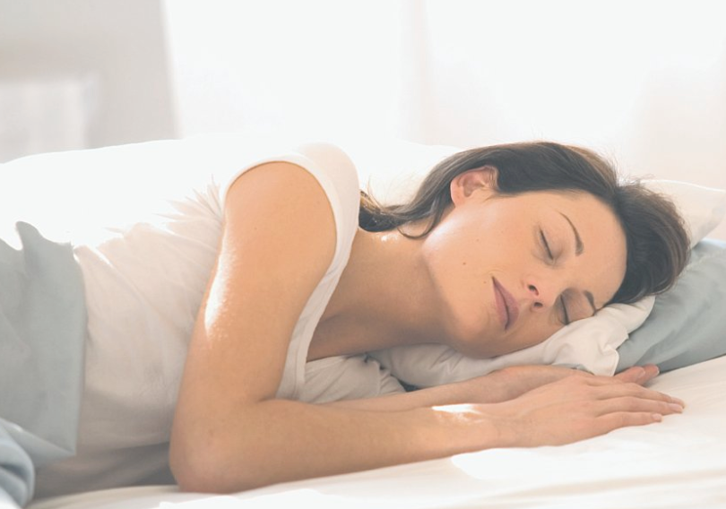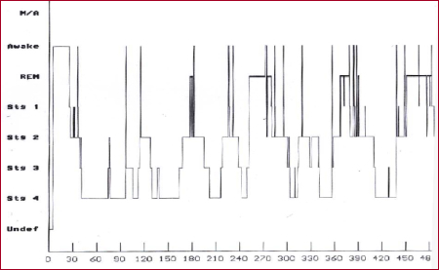

 |  |  | Multiple screens for detail (Y/N)? |  |  |  | N
Development:  Actions/Callouts/  Interactivity |  |  |  |  | Onscreen Text |  |  |  | Audio Script
 | Image (e.g. Brain activity via EEG.) displayed at the same time the audio text is delivered.  Image (e.g. Stages to convey architecture of sleep.)  Onscreen text displays at the same time the audio script is said/delivered. |  |  |  | The advent of electroencephalogram (EEG) allowed us to understand:  - Sleep is not a uniform state of rest  - Sleep is an intricate series of stages organized into cycles that we refer to as the architecture of sleep. |  |  |  | Prior to the ability to look at brain activity (via electroencephalograms, or EEG), sleep was considered an inactive brain state, with no real distinction from other inactive states (eg, coma or stupor).  The advent of EEG, allowed us to understand that sleep is not a uniform state of rest, but rather an intricate series of stages organized into cycles that we refer to as the architecture of sleep.
 |  |  |  |  | Navigation: | Auto-continue

Chapter Name: The Importance of Sleep
Screen Number:
Screen Title |  | Basics of sleep: Stages of Sleep
Screen layout or graphic
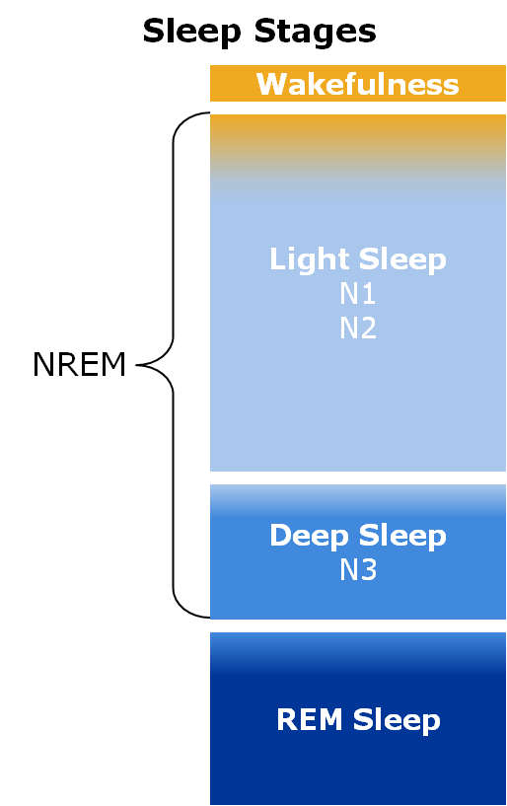

Explore screen layout for Wakefulness

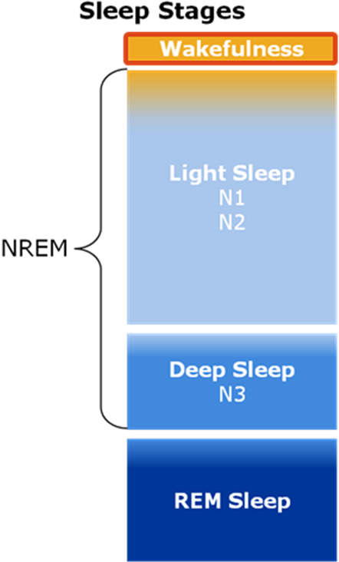

screen layout for Explore NREM
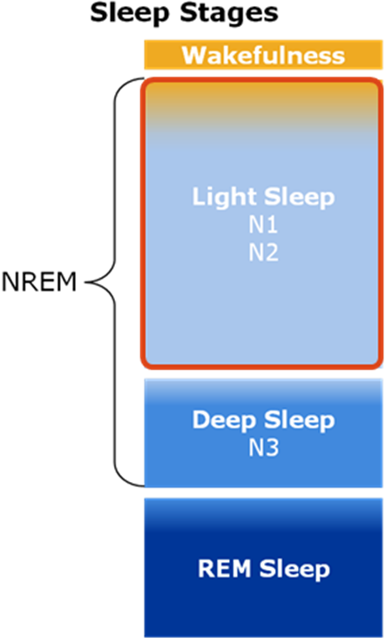

screen layout for Explore REM

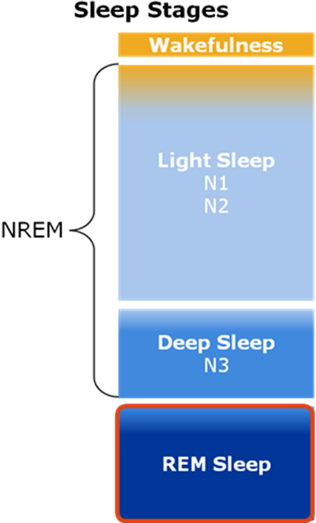

 |  |  | Multiple screens for detail (Y/N)? |  |  |  | Y
Development:  Actions/Callouts/  Interactivity |  |  |  |  | Onscreen Text |  |  |  | Audio Script
 | Images that convey Wakefulness, Non-Rapid Eye Movement (NREM), and Rapid Eye Movement (REM)  Images fade-in and stay on screen as the onscreen text displays. Also have the onscreen content display at the same time, the audio script is delivered.  Click the three unique processes to explore more information. |  |  |  | There are three unique states we refer to when studying sleep:  - Wakefulness  - Non-Rapid Eye Movement (NREM)  - Deep Sleep - Does Stage N3 go here… do we define this yet or change the image we have on file?  - Rapid Eye Movement (REM)  Click the three unique processes to explore more information. |  |  |  | There are three unique states we refer to when studying sleep:  - Wakefulness  - Non-Rapid Eye Movement (NREM), which is divided into light sleep and deep sleep.  - NM Comment: (NOTE: Deep sleep is a sub-category of NREM sleep) Rapid Eye Movement (REM)  Click each stage to explore more information.
 | Image’s sections illuminate Wakefulness and fade-out as the respective onscreen text displays. Also the onscreen content display at the same time, the audio script is delivered. |  |  |  | Wakefulness (Stage W)  - Normally, we spend 5% of our total sleep time (TST) in a state of wakefulness.  - During this stage, the sleeper may range from full alertness through to the early stages of drowsiness.
 | Image’s sections illuminate NREM sleep and fade-out as the respective onscreen text displays. Also the onscreen content display at the same time, the audio script is delivered. |  |  |  | NREM sleep (further divided into 3 stages) Stages 1 and 2:  - During stages 1 and 2 (also called light sleep), the sleeper experiences easy arousals (brief awakenings from sleep).  - The sleeper may only spend 10 – 15 minutes in light sleep (depending on tiredness).
 | Image’s sections illuminate Deep Sleep and fade-out as the respective onscreen text displays. Also the onscreen content display at the same time, the audio script is delivered. |  |  |  | Deep Sleep (Stage N3):  - During stage 3 (also called deep, delta or slow wave sleep/SWS).  - The sleeper experiences a very high threshold to arousal. This state can last up to 40 minutes.
 | Image’s sections illuminate REM Sleep and fade-out as the respective onscreen text displays. Also the onscreen content display at the same time, the audio script is delivered. |  |  |  | REM Sleep:  - REM sleep is not divided into stages. It occurs roughly every 90 minutes and progressively increases in duration over the course of the night.  - This is the stage where most dreaming occurs.
 |  |  |  |  | Navigation: | Continue Once all States are displayed?

Chapter Name: The Importance of Sleep
Screen Number:
Screen Title |  | Basics of sleep: What happens to the body during each stage?
Screen layout or graphic


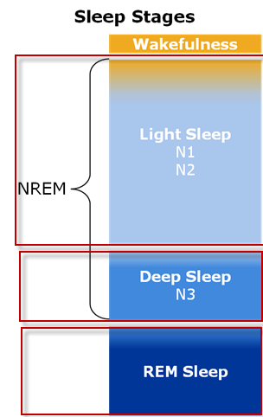

NM Comment: Maybe use this image for light sleep and a darker image for deep sleep.
Need Image for Deep Sleep N3

Arrows not meant to be on screens… just to help callout for storyboard.
 |  |  | Multiple screens for detail (Y/N)? |  |  |  | Y
Development:  Actions/Callouts/  Interactivity |  |  |  |  | Onscreen Text |  |  |  | Audio Script
 | Images that convey NREM1, NREM2, NREM3, and REM. Also, possible corresponding images to convey those stages? Note: Arrows provided just for storyboard purposes.  Image’s sections illuminate NREM Stage 1 and fade-out as the respective onscreen text displays. Also the onscreen content display at the same time, the audio script is delivered. |  |  |  | Each sleep stage has physiological effects on the body. See what happens in each stage:  NREM Stage 1:  - Transitional stage from wakefulness to sleep.  - The body begins to relax and muscle jerking/twitching is fairly common. |  |  |  | Each sleep stage has physiological effects on the body. See what happens in each stage:  NREM Stage 1:  - This is a transitional stage from wakefulness to sleep.  - During this stage, the body begins to relax and muscle jerking/twitching is fairly common.
 | Image’s sections illuminate NREM Stage 2 and fade-out as the respective onscreen text displays. Also the onscreen content display at the same time, the audio script is delivered. |  |  |  | NREM Stage 2:  - As the body further relaxes, breathing and heart rate slow down. |  |  |  | NREM Stage 2:  - As the body further relaxes, breathing and heart rate slow down and become regular.
 | Image’s sections illuminate NREM Stage 3 and fade-out as the respective onscreen text displays. Also the onscreen content display at the same time, the audio script is delivered. |  |  |  | NREM Stage 3:  - This is the deepest sleep of all stages.  - This stage reveals the slowest breathing and heart rate of the night.  - Restores to the body.  - The sleeper is very difficult to arouse, and there are no eye movements. |  |  |  | NREM Stage 3:  - This is the deepest sleep of all stages.  - This stage reveals the slowest breathing and heart rate of the night.  This stage is restorative to the body. The sleeper is very difficult to arouse, and there are no eye movements.
 | Image’s sections illuminate REM and fade-out as the respective onscreen text displays. Also the onscreen content display at the same time, the audio script is delivered.  This slide will have to be duplicated to fit this much onscreen text. |  |  |  | REM:  - Characteristics of REM sleep include:  - Bursts of rapid eye movement  - Almost a complete loss of muscle tone (voluntary muscles)  - EEG activation (electrical activity from the brain)  - Mental activity associated with dreaming.  - REM sleep can be thought of as a highly active brain in a paralyzed body. This paralysis acts as a safeguard to prevent a person from acting out their dreams.) |  |  |  | REM:  - Characteristics of REM sleep include:  - Bursts of rapid eye movement  - Almost a complete loss of muscle tone (voluntary muscles)  - EEG activation (electrical activity from the brain)  - Mental activity associated with dreaming.  - REM sleep can be thought of as a highly active brain in a paralyzed body. This paralysis acts as a safeguard to prevent a person from acting out their dreams.)
 |  |  |  |  | Navigation: | Continue Once all Stages are displayed.

Chapter Name: The Importance of Sleep
Screen Number:
Screen Title |  | Basics of Sleep: Sleep Cycles
Screen layout or graphic

NM Comment: Do not use the hypnogram image here. Instead, consider using image from slide 7 of the Diabetes course (in reference materials).
Greg Reply: Please upload the PPT for Diabetes Course as I do not see it on the FTP site.

Image of a clock, just not the same one used before.

Can use the same bar graph from previous screen?

 |  |  | Multiple screens for detail (Y/N)? |  |  |  | Y
Development:  Actions/Callouts/  Interactivity |  |  |  |  | Onscreen Text |  |  |  | Audio Script
 | Images that convey 8 hours of time (clock).  Show a graph (3 bars) of time spent in each cycle?  Show an animation of a sleep cycle going through various stages? E.g. hypnogram?  The onscreen text displays at the same time, the audio script is delivered. |  |  |  | - Normally, we sleep an average of 7 – 8 hours per night.  - Spend more time in Stage 3 NREM (deep sleep) in the first third of the night and more time in REM sleep in the last third of the night.  - Throughout the night we cycle through the various stages of sleep approximately every 90 -110 minutes.  - A sleep cycle includes both NREM and REM phases and generally, the end of the first REM phase is the completion of the first sleep cycle.  - Once a person has completed the first sleep cycle, they may not begin again with Stage 1 and go through every stage. It is possible to begin subsequent cycles at Stage 2, go to Stage 3 and follow with REM. |  |  |  | Normally, we sleep an average of 7 – 8 hours per night and we spend more time in Stage 3 NREM (deep sleep) in the first third of the night and more time in REM sleep in the last third of the night.  Throughout the night we cycle through the various stages of sleep approximately every 90 -110 minutes. A sleep cycle includes both NREM and REM phases and generally, the end of the first REM phase is the completion of the first sleep cycle.  Once a person has completed the first sleep cycle, they may not begin again with Stage 1 and go through every stage. It is possible to begin subsequent cycles at Stage 2, go to Stage 3 and follow with REM.
 |  |  |  |  | Navigation: | Auto-Continue

